 Project Report Template

1. **INTRODUCTION** 
   1. Overview

A brief description about performance of Radisson Hotels.

* 1. Purpose

The use of this project.

A guest’s plans a trip, or an investor or owner is thinking of a partner, or whenever someone is looking for a career in the hospitality industry, they will all think of Radisson Hotels Group up first.

**2 Problem Definition & Design Thinking**

2.1 Empathy Map

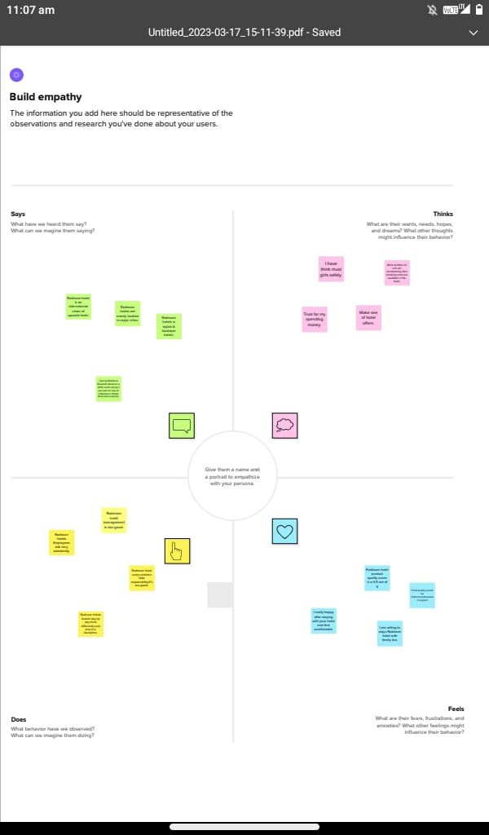

2.2 Ideation & Brainstorming Map

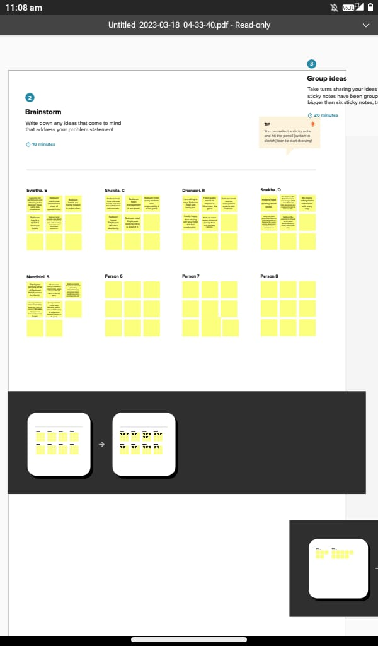

1. **RESULT**

It places Radisson Hotel Group amongst top companies in the World who align with cop climate goals and et their carbon reduction targets according to science.

1. **ADVANTAGES & DISADVANTAGES**

Advantages for Radisson hotels:

* Breakfast & dinner service is always nice and professional room is clean and tidy.
* The hotel is at a prime location in the city.
* The staff is very friendly and accommodating.

Disadvantages for Radisson hotels:

* The variety of breakfast selection is very limited.
* The hotel said it will set up the extra bed for the 3rd people but does not set up will the end.

1. **APPLICATIONS**

* Free upgrades for the guest’s next visit.
* Complimentary food and beverage items at the hotels.

1. **CONCLUSION**

At Radisson hotels group we strive to the first choice in the mind of guests, owners and talent.

1. **FUTURE SCOPE**

Radisson hotels Group, one of the World’s leading hotels groups, has received confirmation and validation of its near-term Science Based Targets aligned with its commitment to be Net-Zero by 205

